From movement to predation: metabolism rules all

Flavio Affinito1, Miguel Matias2, Samraat Pawar1 and Rebecca L. Kordas1

1. Department of Life Sciences, Imperial College London, Silwood Park Buckhurst Road, SL5 7PY, Ascot UK

2. Museo Nacional de Ciencias Naturales (CSIC), Madrid, 28006, Spain

Formatted for Functional Ecology

Title: currently 6802 words (including references) / 7500 max.

Abstract: currently 0 words / 350 max.

Figures: 1-7

Tables: 0

Equations: 8

Keywords: 9/8 max

References: currently 53[1]

**Abstract**

**1.**

**2.**

**3.**

**4.**

**5.**

**Keywords:** adaptation, temperature performance curve, respiration, search rate, velocity, metabolic rate, predator-prey, modelling, mismatch

**Introduction**

The past 50 years revealed the fastest rise in temperatures ever recorded (Houghton, 1996; Stocker, 2014). These environmental changes affect the wide range of ecological processes and biological traits directly dependent upon temperature (Coley *et al.*, 1985; Loreau *et al.*, 2001). Temperature is arguably the most important abiotic factor directing ecological processes, from individual metabolism (Gillooly *et al.*, 2001) to ecosystem dynamics (Saxe *et al.*, 2001; Yvon-Durocher *et al.*, 2012). This rapid increase in temperatures is having a direct impact on species and their interactions (Hughes, 2000; Penuelas and Filella, 2001). Despite the body of work on how temperature affects biological rates (Gillooly *et al.*, 2001; Brown *et al.*, 2004), we still lack the necessary understanding to predict how future changes in global temperatures will affect species interactions. Locally, species adaptation to new thermal environments causes mismatches in predator-prey dynamics (Dell *et al.*, 2011). Biochemical processes direct these adaptations (Angiletta, 2009; De Long *et al.*, 2017). Here, we aim to understand which are the drivers of adaptation and quantify how changes in these biochemical processes affect predator-prey dynamics via their effect on search rates.

Thermal performance curves (TPCs) of biological traits are key to understanding how temperature affects biological processes. The metabolic theory of ecology describes the relationship between temperature and metabolism (Brown *et al.*, 2004). Support for this theory has been found both in studies of metabolic rate (Dell *et al.*, 2011; Gillooly *et al.*, 2001) and other biological traits (Savage *et al.*, 2004; Vucic-Pestic *et al.*, 2011). Metabolic rates display a unimodal relationship with temperature due to biochemical processes occurring at high temperatures (Angilletta, 2006; DeLong *et al.*, 2017b; Figure 1A). Work on temperature performance curves has revealed various scenarios of adaptation to new thermal conditions (Kingsolver, 2009), which have higher-level effects on their population dynamics (Rall *et al.*, 2010; Vucic-Pestic *et al.*, 2011). Changes in habitat temperatures cause physiological changes resulting in several TPC adaptation patterns. These include displacement in temperature at peak performance (determined by *Tpk*, Figure 1b) and changes in the curve’s elevation (determined by the performance parameter *b0*, Figure 1c) (Angilletta, 2009). These adaptations have consequences on species interactions by producing mismatches in performance between predators and their prey (Dell *et al.*, 2014). Most species currently perform differently throughout their operational temperature range (OTR) (Figure 1D), with prey usually under evolutionary pressure to outperform predators at the bottom of the range (Dell *et al.*, 2011). As species adapt to new environments, new mismatches will arise and lead to new interactions. These in turn will increase consumption rates, modify community dynamics and could lead to changes in ecosystem assemblage and increased extinction risk (Albouy *et al.*, 2014; Rall *et al.*, 2010).

Body velocity affects predator search rates, driving predator-prey interactions (Mc Gill & Mittelbach, 2006; Pawar *et al.*, 2012; Dell *et al.*, 2014). In part, the energy produced from respiration will be used up for muscle contraction and locomotion (Alexander, 2003). Research on animal locomotion suggests specific relationships between the energetic cost of transport and metabolic rate based on locomotion type (Tucker, 1970; Videler and Nolet, 1990; Videler, 1993; Alexander, 2003; Hein *et al.*, 2012; Gibert *et al.*, 2016). Thus, local adaptation of respiration TPCs will induce changes in velocity TPCs in turn affecting predator-prey ability to forage or escape. Temperature dependence of search rates has been suggested (Rall *et al.*, 2012) but proper mechanistic understanding of the relationship is lacking.  Search rates are determined both by the biological traits of the resource and its consumer and by environmental conditions. In addition to temperature, environmental dimensionality has been shown to have an effect on search rates (Pawar *et al.*, 2012). Biotic effects on search rates are determined by the relative velocity of the predator and its prey (Dell *et al.*, 2014). We consider how local adaptation of metabolic rates drives adaptation of species velocity and how the arising mismatches result in altered predator search rates.

Comprehensive mechanistic modelling of the effect of metabolism on higher level processes promises to yield invaluable insight into the biochemical processes directing ecology (Dell *et al.*, 2014; Gibert & DeLong, 2014; Pawar *et al.*, 2015). Here, we develop a model to predict species interaction rates from individual-level metabolic (specifically respiration) rates. Bridging the gap between basal biochemistry, velocity and search rates via robust mathematical modelling allows for predictions of seldom measured search rates using commonly acquired respiration rates (Gillooly *et al.*, 2001; Brown *et al.*, 2004; Dell *et al.*, 2011; Huey & Kingsolver, 2011). We support our theoretical approach by integrating empirical work to understand the relationship between biological traits and species interactions with temperature. We used a space for time substitution for adaptation by sampling three taxa of aquatic invertebrates from a large mesocosm experiment set up in the Iberian Peninsula with sites located in regions varying in mean temperature. All three species of interest are widespread insects in Europe and fill different ecological niches: top predator, intermediate consumer and bottom-feeder. These taxa are locally adapted, which enabled us to detect the effect of warming on their respective TPCs. We looked for temperature-induced mismatches in the TPCs of velocity, to predict changes in species interactions for locally adapted populations.

To understand how adaptation to increases in global temperatures will affect species interactions, we investigate whether metabolic rate TPCs change between locally adapted populations, what parameters drive these changes and what effect these have on individuals species’ velocity and predator-prey search rates. We analysed respiration TPCs of locally adapted populations to (i) test for expected adaptation scenarios in metabolic rates and (ii) analyse changes in biological parameters driving adaptation. We then investigate (iii) how adaptation of respiration TPCs cause mismatches in velocity TPCs of predator-prey pairs. Finally, we (iv) consider the effects of local adaptation in velocity on predator search rates and (v) how adaptation to a warm environment changes search rate parameters.



Figure 1. **Metabolism set the pace of life, directing all biological traits.** Metabolic rates can be modelled as a unimodal function (A) determined by biochemical processes (enzyme activation (*Ea*) and deactivation (*Ed*) energies) and biological parameters (*Tpk* and *b0*) from equation 8. Adaptation to increases in temperature can give rise to different patterns. Vertical shifts in performance (B) as *b0* changes with temperature or horizontal displacement in the whole TPC (C) as species adapt to a new *Tpk*, are expected to arise. This may lead to new mismatches in predator-prey traits, potentially affecting their dynamics at specific temperatures (D-E). Adapted from Angilletta, 2009; Kingsolver, 2009 ; Dell *et al.*, 2014.

**Modelling**

THE SEARCH RATE MODEL

Predator-prey interactions are typically modelled using Holling’s type II functional response equation, dependent on two key parameters: search rate (*a*) and handling time (*h*) (Holling, 1959). In biologically realistic conditions, where prey abundance in the environment does not reach high enough numbers to cause predator satiation, handling time (*h*) can be ignored (*h = 0*). Thus only the dynamics of the rising, search rate dominated, part of the disk equation will take place. Search rate determines the number of attacks a predator will conduct and is defined as *a*: the area, or volume, a predator will be able to look for a prey every second. The mechanistic underpinnings of search rates are determined both by biological and environmental factors (Mc Gill & Mittelbach, 2006; Pawar *et al.,* 2012). Pawar *et al.* (2012) have shown that search rates can be modelled by considering a predator-prey pair’s relative velocity and the environment they interact in. The effect of dimensionality on search rate depends on whether the predator is foraging in a 2D or 3D environment and scales as follows:

|  |  |  |
| --- | --- | --- |
|  | $$2D :a=v_{r}2d_{0}{(m_{c}m_{r})}^{p_{d}}$$ | (1) |

|  |  |  |
| --- | --- | --- |
|  |  | (2) |

Where *vr* is the relative velocity of the prey and predator, *d0* is the minimum detection distance, *mc* and *mr* are predator and prey mass respectively and *pd* is the scaling exponent of mass with dimensionality. The values of *pd* in 2D and 3D are 0.68 and 1.05 respectively (Pawar *et al.*, 2012).

The energetic power needed to put an individual in motion is provided by metabolism. Metabolic rates display a unimodal response to temperature (Angilletta, 2009). As all biological rates are intrinsically determined by an individual’s metabolic rate, they are expected to follow a similar relationship to temperature (Pawar *et al.,* 2012; Dell *et al.*, 2014). Velocity is one such rate and will thus follow a scaling relationship akin to that of metabolic rates (Brown *et al.*, 2004; Dell *et al.*, 2014). For two species moving in random directions in the same environment, their relative velocity depends upon respective velocities of each species (Dell *et al.*, 2014). Hence we can scale *vr* with temperature adding equations 1 or 2 (as *D*):

|  |  |  |
| --- | --- | --- |
|  | $$a= \left(b_{0,c}{m_{c}}^{β_{c}}e^{\frac{{-E}_{c}}{k}\left(\frac{1}{T}-\frac{1}{T_{ref}}\right)}+\sqrt{1+{\left(\frac{b_{0,r}}{b_{0,c}}\right)}^{2}{\left(\frac{{m_{r}}^{β_{r}}}{{m_{c}}^{β_{c}}}\right)}^{2}e^{\frac{2}{k}\left(\frac{1}{T}-\frac{1}{T_{ref}}\right)\left(E_{c}-E_{r}\right)}}\right)D$$ | (3) |

Where *b0* is the normalisation constant for velocity at a reference temperature (*Tref*) set here at each site’s mean temperature, *m* is mass, *β* is the mass scaling exponent, *E* is activation energy, *T* is temperature, *k* is Boltzmann’s constant and *c* or *r* subscripts correspond to predator and prey parameters respectively. This model predicts the search rate of a predator foraging on an active moving prey in different environments. It can be adapted to a scenario for sessile prey (prey velocity = 0) by setting the prey’s velocity to 0:

|  |  |  |
| --- | --- | --- |
|  | $$a= b_{0,c}{m_{c}}^{β_{c}}e^{\frac{{-E}_{c}}{k}\left(\frac{1}{T}-\frac{1}{T_{ref}}\right)}D$$ | (4) |

There are known limitations to this model: measured metabolic rates are used as a function of velocity without taking into account other energetic needs (the whole budget goes to velocity) or increases in metabolism during activity and the efficiency of energy conversion by muscles is ignored. Nevertheless, this model is expected to provide us with a mechanistic prediction of predator search rates in various conditions and for any given species where mass and metabolic rates are known.

The model’s output was plotted for predator-prey pairs adapted to warm and mild environments to observe the effect of local adaptation on search rates. We then estimated search rate *Ea* and *b0* at each site and for each strategy and plotted the changes in parameter values.

VELOCITY CALCULATION

Oxygen, in animals, is absorbed for respiration in order to produce energy that can later be used for bodily functions. We use oxygen consumption (respiration) rate as a proxy of metabolic rate, which we then convert to body velocity assuming that velocity scales linearly with metabolic rate (Tucker, 1970; Alexander, 2003). Elliott and Davison (1975) have shown that the average production of energy, via the combustion of carbohydrates, fat and protein, yields 3.34 calories per *mg* of oxygen. Oxygen consumption, measured in *μmol/h* can be converted to *g.h-1* by multiplying by the atomic mass of *O2*: 31.988 *g.mol-1*. This in turn can be turned into *cal.h-1* by using the mean oxidation value of 3.34 *cal.mg-1*. The laws of thermodynamics show that 1cal yields 4.1868*J*. This provides us with a measurement of energy produced by respiration in *J.s-1*. The energetics of animal movement, and specifically swimming, have been extensively studied for various species (Videler and Nolet, 1990; Videler, 1993; Alexander, 2003). This work reported a relationship between cost of transport (*COT*), the amount of energy in *J* needed to transport 1*N* over 1*m* in submerged swimmers, and metabolic rate (*B*). Rearranging Videler’s equation for velocity yields:

|  |  |  |
| --- | --- | --- |
|  | $$v= \frac{B}{COTmg}$$ | (5) |

Where *COT* is expressed in *J.Nm-1*, *B* is in *J.s-1*, *m* is mass in *kg*, *g* is gravitational acceleration in *m.s-2* and *v* is speed in *m.s-1*. *COT* was calculated from Videler’s relationship (Videler, 1993):

|  |  |  |
| --- | --- | --- |
|  | $$COT=1.1m^{-0.038}$$ | (6) |

Where *m* is mass in *kg*. Metabolism temperature performance curves of each predator-prey pair per site were thus converted into a measure of velocity using equations 5 and 6.

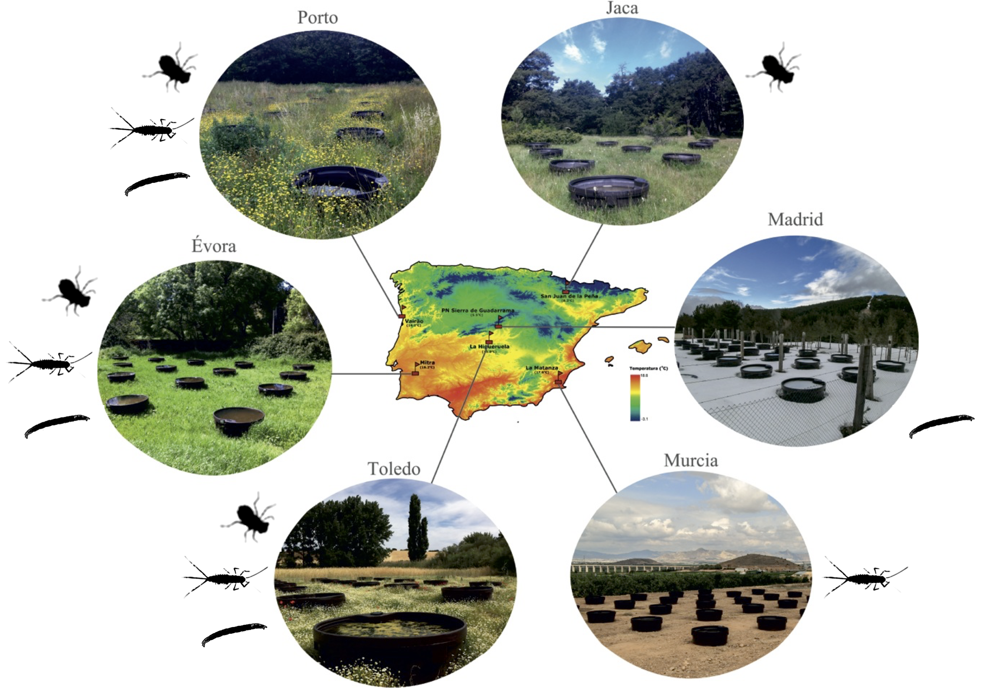

Figure 2. **The IberianPonds network is located in the thermally diverse Iberian peninsula.** The location of all six mesocosm experimental sites is shown with respect to a thermal map of the peninsula. Individual taxa sampled at each site are displayed (Jaca: *S. striolatum* alone; Madrid: *Chironomus* spp. alone; Murcia: *C. cloeon* alone). Taken from Matias (unpublished).

**Empirical Methods**

STUDY SITES

To determine whether taxa adapt to warmer conditions we used a space for time substitution and measured oxygen consumption rates of target species at six sites that varied in altitude and environmental conditions. These sites were spread throughout the Iberian Peninsula (Figure 2). At each site 32 artificial mesocosm ponds of 320L volume capacity were set up and initially seeded in 2015 with an assemblage of locally sampled freshwater species. The communities in these ponds were then left to assemble naturally over the following two years. Most invertebrate species found in the ponds are efficient dispersers upon reaching adult stage and were found throughout ponds at each site (Matias, unpublished data). The sampling period for this study corresponded to the local spring season at each site (April to May). The distinct geographical position of these sites exposed them to different local climates and average temperatures: Peñalara (7.35±0.05°C), Jaca (11.05±0.04°C), Porto (12.7±0.03°C), Toledo (13.47±0.03°C), Évora (14.92±0.03°C) and Murcia (16.23±0.03°C). Mesocosm temperatures were recorded with submerged loggers every hour since the set up of each experimental site.

STUDY ORGANISMS

Experiments in this study were carried out on macro invertebrates native to ponds of the Iberian Peninsula. We targeted species based on site abundance (>100 individuals) and trophic level (predator vs prey). Not all species were found in sufficient numbers at all six sites (Figure 2). Feeding trials were carried out at each site to assess consumer links. Potential predator species (1 individual) were isolated and left overnight in water filled arenas (50*mL*) with expected prey species (2 individuals). These trials revealed a predatory relationship between the dragonfly species *Sympetrum striolatum* and two prey taxa, the mayfly species *Cloeon dipterum* and the chironomid genus *Chironomus* (Figure S1).

Differences in morphology and locomotive behaviour are expected to produce different foraging strategies for the predator with each prey type. During larval stage both the mayfly and dragonfly, as pelagic species, can be found swimming in the water column. *C. dipterum* is an fast swimmer found mostly in clear areas of the water column (Merritt *et al.*, 1996; Bauernfeind and Soldan, 2012). *S. striolatum* is found mostly within macrophytes and is capable of bursts of speed when attacking its prey (Merritt *et al.*, 1996). In contrast, *Chironomus* spp. are benthic and found mostly hiding in the sediment (Cranston *et al.*, 1995). As both *C. dipterum* and its predator are pelagic species, we expect this relationship to correspond to a foraging strategy defined as ‘active capture’ where both predator and prey velocities affect model predictions. *Chironomus* spp. are benthic, hence their relative velocity upon encounter with a predator is likely to be negligible, corresponding to a foraging strategy defined as ‘sessile prey’ (Pawar *et al.*, 2012).

Individuals were collected with 500*μm* mesh nets from their home ponds and were identified to species level following experiments and preservation. Any experiments done with the wrong species were excluded (16.8% of chironomids, 8.5% of mayflies and 9.6% of dragonflies).

EXPERIMENTAL DESIGN

We measured oxygen consumption over time as a proxy for metabolic rate (Angilletta, 2009). Measures of metabolic rates were carried out using standard respiration protocol (Supplementary material, (Brodersen *et al.*, 2008)) with Unisense oxygen sensors (Unisense, Denmark). We carried out respiration trials for all three taxa from each of the sites at 5°C intervals from 10°C to 45°C in order to capture both the activation and deactivation energy of respiration. Water temperature was controlled using a water bath. Two trials of 7 to 14 individuals each, were carried out at each experimental temperature (Table S1). Prior to respiration experiments sampled individuals were stored for 24*h* in pond water filtered with 53*μm* followed by 20*μm* mesh nets and held at ambient temperature. This allowed for gut clearing of all experimental individuals.

In order to calculate individual dry mass a minimum of 50 individuals per taxa were collected from Murcia, Évora and Toledo. These were measured and dried in the oven at 80°C for 24*h* before being weighed. Length-weight regressions were estimated from these data (Supplementary material). Following experiments and preservation all other individuals were measured and dry weight was estimated from the regressions.

We then fit a set of TPC models to the measured oxygen consumption rates. The metabolic theory of ecology (MTE) (Brown *et al.*, 2004) predicts that enzymatic activation energy scales linearly with the inverse of temperature following an Arrhenius function:

|  |  |  |
| --- | --- | --- |
|  | $$\ln\left(B\right)= -E_{a}\frac{1}{kT}+ln⁡(B_{0})$$ | (7) |

Where *B* is the metabolic rate, *Ea* is the enzyme’s activation energy, *k* is Boltzmann’s constant, *T* is the temperature (in *K*) and *B0* is the normalisation constant.

The Schoolfield model (Schoolfield et al., 1981) describes metabolic rate based on enzyme kinetics. This measures metabolic rate as a function of temperature including the enzyme’s temperature deactivation energy past the peak performance temperature. We used a simplified version of the model that ignores low temperature inactivation as not enough measurements were available to estimate it:

|  |  |  |
| --- | --- | --- |
|  | $$B= \frac{b_{0}m^{β}e^{\frac{-E_{a}}{k}\left(\frac{1}{T}-\frac{1}{T_{ref}}\right)}}{1+ e^{\frac{E_{d}}{k}\left(\frac{1}{T_{pk}}-\frac{1}{T}\right)}}$$ | (8) |

Where B is oxygen consumption rate, *b0* is the normalisation constant at a reference temperature (*Tref* ), *m* is mass, *β* is its scaling exponent, *Ea* is the enzyme’s activation energy, *Ed* is its deactivation energy, *k* is Boltzmann’s constant, *T* is temperature and *Tpk* is the temperature at which the *B* is maximised. Each site’s mean temperature was used as reference temperature (*Tref* ) to estimate a biologically relevant value for *b0*. Mass scaling was left as a free parameter to be estimated from the data for both prey taxa and set to *β=0.75* for the predator taxa after a model choice procedure was carried out (Supplementary material). All parameters were thus estimated from this function via non-linear least squares fitting of the model to the data collected for each species at each site using the ”minpack.lm” package (Elzhov *et al.*, 2016) for the statistical software R (R Core Team, 2015). Starting parameters for the fitting were sampled 10,000 times from a normal distribution centred on values estimated from equation 7 to determine the parameter values that yielded a best fit to the data (lowest AIC, BIC and highest R2).

Schoolfield models (equation 8) were fit to all the respiration data for each taxa at each site of occurrence. The best-fit model out of 10,000 runs in each case was kept to estimate the values of *Ea, Ed, b0, β* and *Tpk* (Table S4). Respiration curves were then plotted for each taxa at each site to compare adaptation patterns. Estimated parameter values were then compared between local populations at each site. Parameter values were considered statistically different from each other when associated confidence intervals did not overlap.

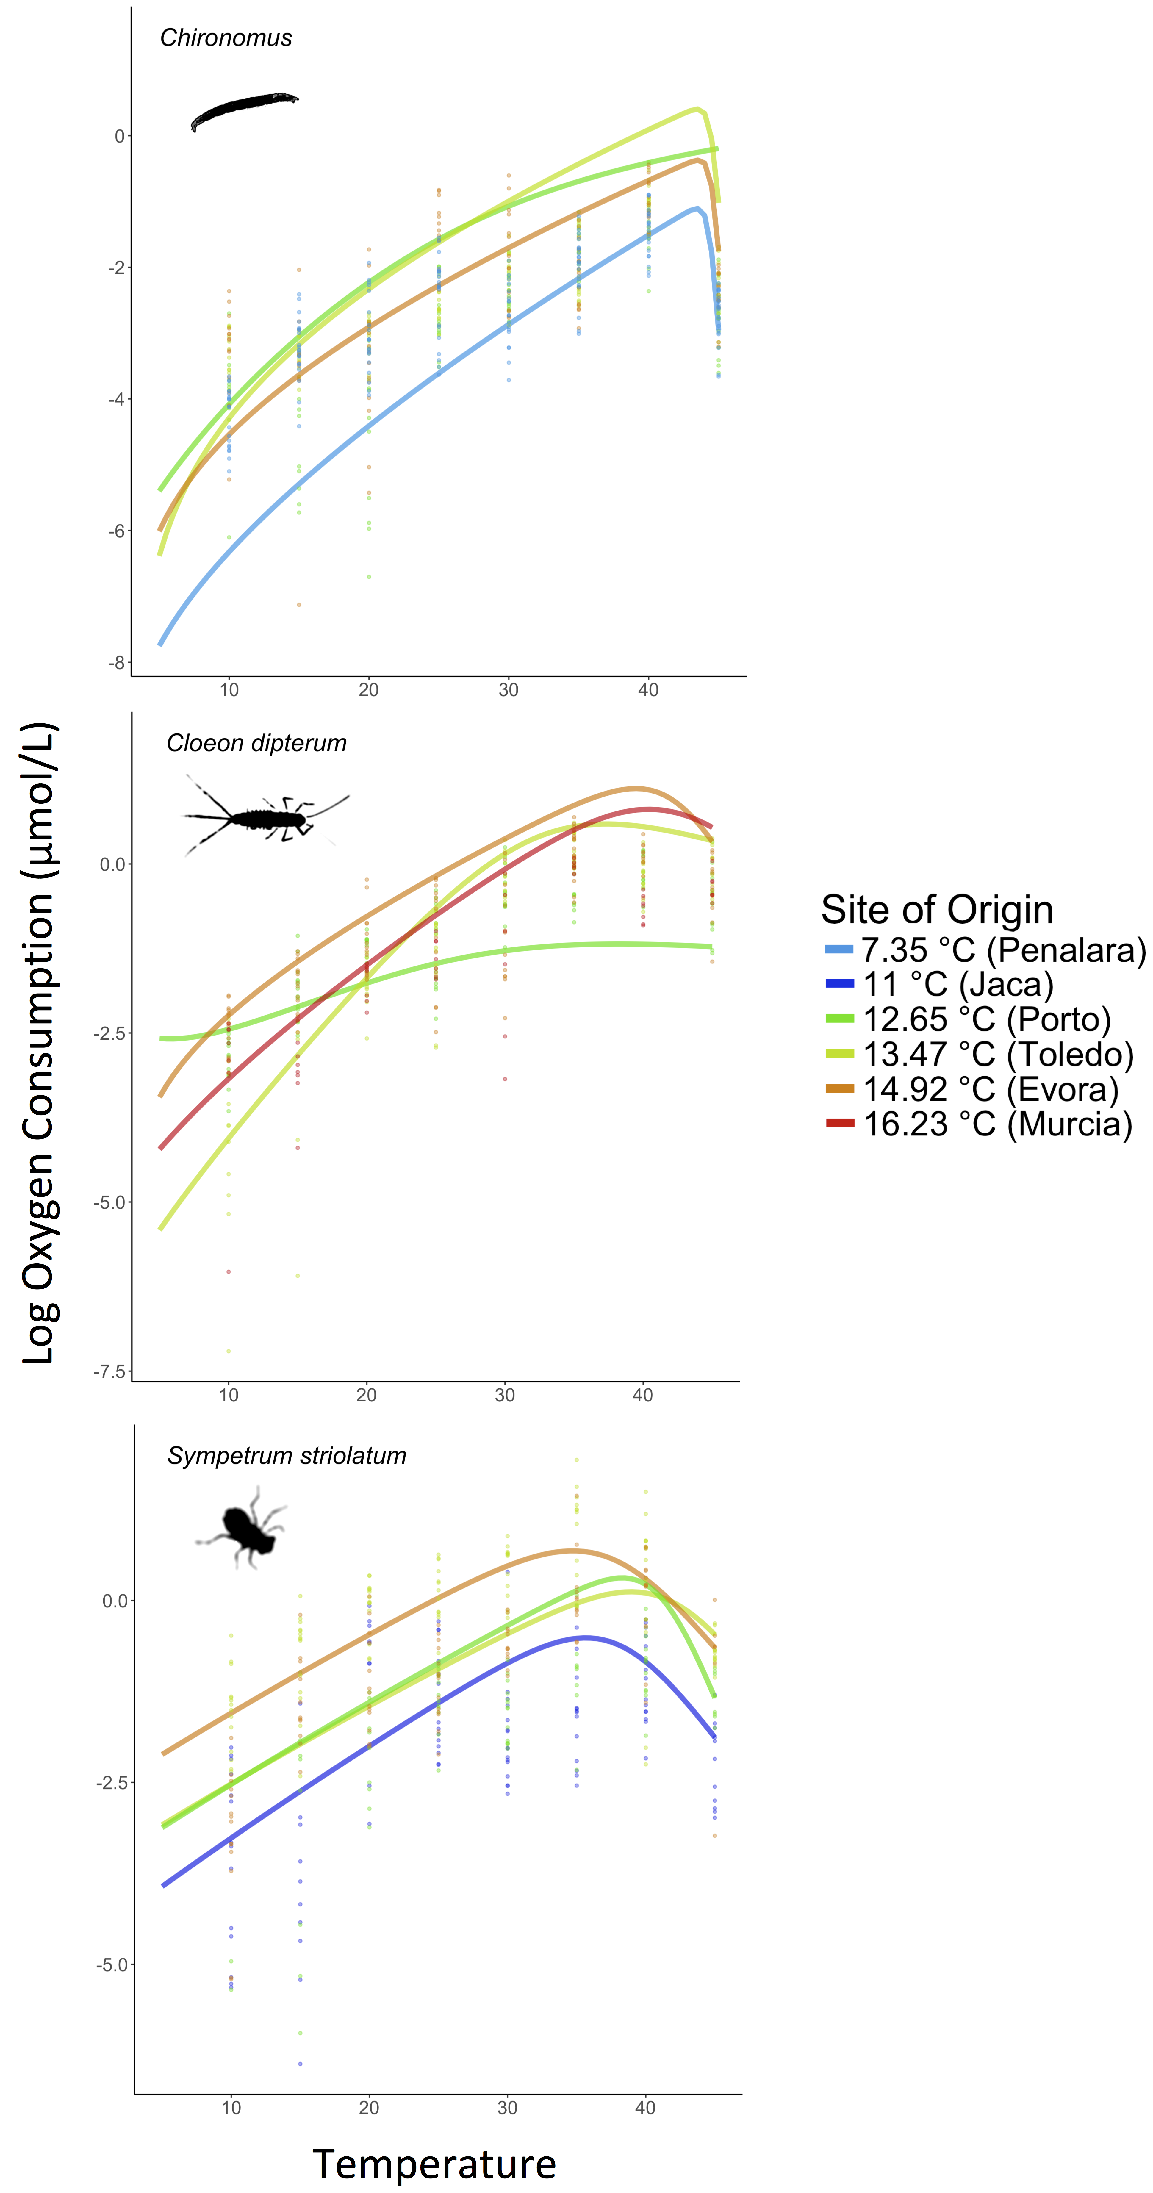

Figure 3. **Species adapt to their surrounding environment, changing their metabolic rates correspondingly.** Respiration temperature performance curves for *Chironomus* *spp*, *C. dipterum* and *S. striolatum* display an adaptation scenario corresponding to that predicted in Figure 1B. Note that curves for the coolest and hottest adapted populations are lower than those for intermediate sites for both prey species.

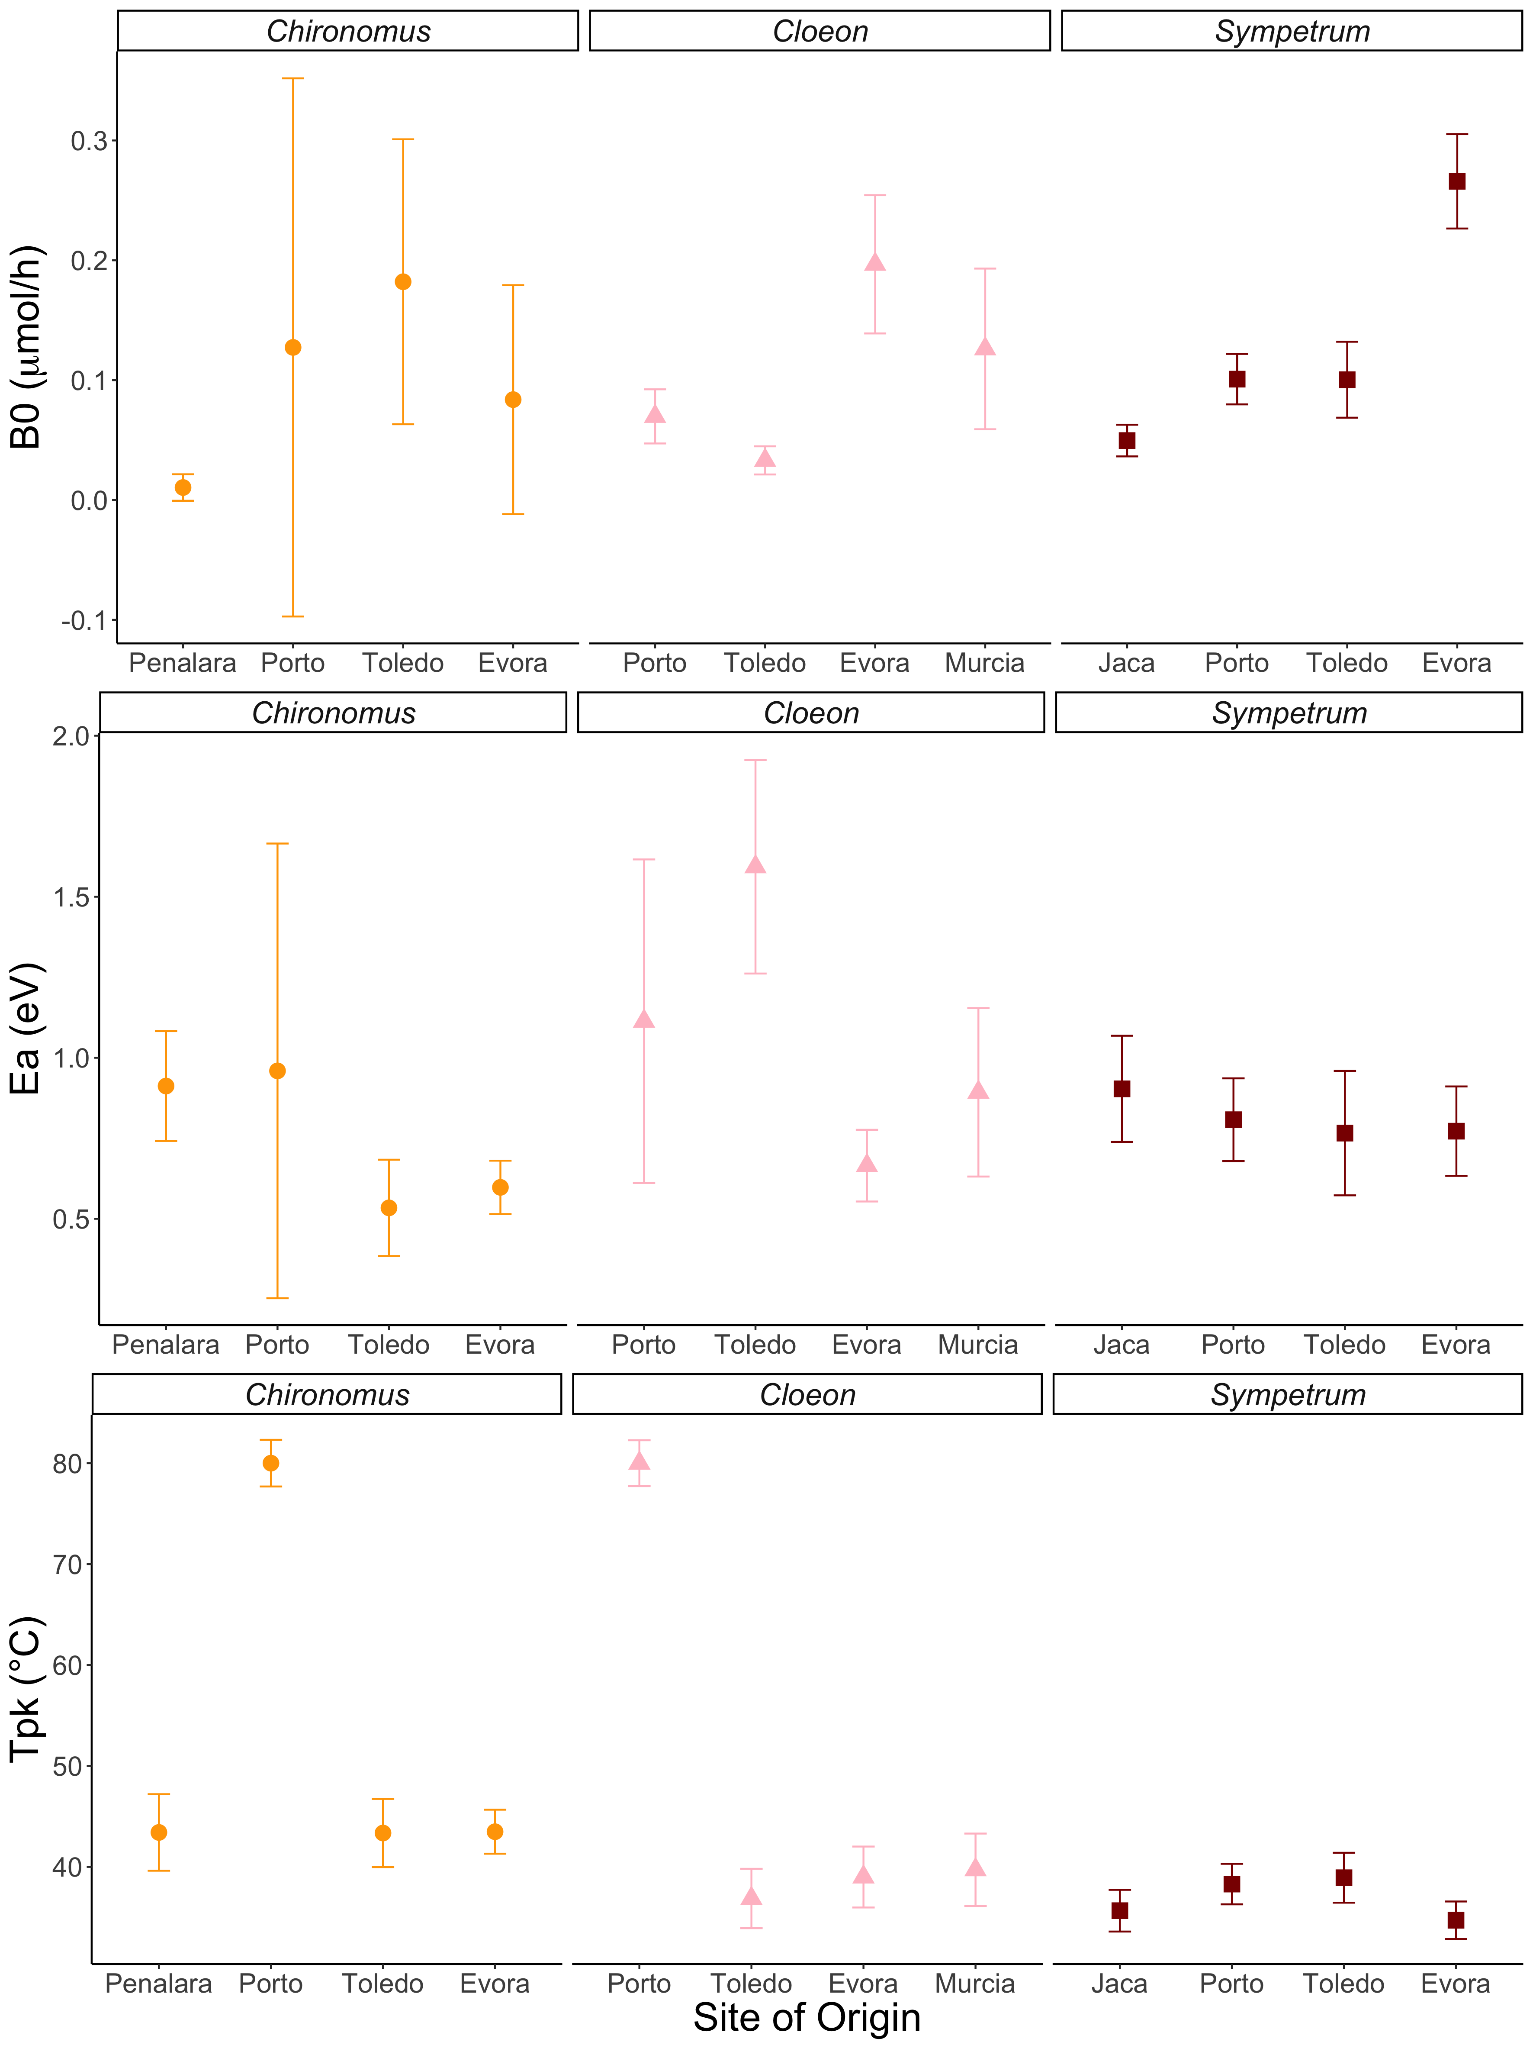

Figure 4. **Differences in Schoolfield model parameter estimates are the origin of the observed variation in TPCs.** Parameter estimates, associated to biological traits, show significant differences in adaptation to local thermal environments within taxa. Note that these significant differences are only *Tpk* when model convergence was poor (Porto).Values for *b0* and *Ea* vary with temperature for each taxa.

**Results**

The temperature dependence of respiration rate

Horizontal shift scenarios in TPC (Figure 1C) between locally adapted populations were not supported for any taxa (Figure 3). We failed to capture the falling part of the curve in Porto for both prey taxa resulting in model estimate of *Tpk* at the maximum valued allowed by the NLS fit: 80°C. At all other sites, temperature of peak performance for each taxa did not vary significantly as all *Tpk* confidence intervals overlapped (Figure 4). All three taxa adapted to new thermal environments by shifting their TPCs vertically (Figures 1B & 3). We recorded an increase in *b0* with site temperature for the predatory *S. striolatum*, *C. dipterum* displayed higher elevation for the warmer two sites in contrast to the cooler two and *Chironomus* spp. TPCs appeared to have higher *b0* at intermediate temperatures than at either extreme (Figures 3 & 4). Significant variation in *Ea* was recorded for both prey taxa in the cooler sites, with colder adapted populations showing steeper activation energies (Figure 4). No difference in activation energy between sites was found for *S. striolatum* (Figure 4).

As with respiration, no changes in velocity temperature performance curve *Tpk* were observed (43.5±3.4°C and 43.5±2.2°C for *Chironomus* spp., 37.4±2.9°C and 39.6±3°C for *C. dipterum*, 39±2.5°C and 34.7±1.9°C for *S. striolatum* in Toledo and Évora respectively). Curve elevation increased for all species: 0.07±0.028*m.s-1* versus 0.09±0.023*m.s-1* for *Chironomus* spp., 0.35±0.002*m.s-1* versus 0.47±0.009*m.s-1* for *C. dipterum* and 0.60±0.004*m.s-1* versus 0.78±0.005*m.s-1* for *S. striolatum* in Toledo and Évora respectively. We found higher elevation of the predator curve relative to the prey at warmer adaptation temperatures for both prey taxa: Δ*b0*=0.52*m.s-1* versus Δ*b0*=0.69*m.s-1* for *Chironomus* spp. and Δ*b0*=0.25*m.s-1* versus Δ*b0*=0.32*m.s-1* for *C. dipterum* in Toledo and Évora respectively. Adaptation to warmer environments increases elevation for all taxa but the relative difference in curve elevation increases as predator *b0* increases faster than that of either prey taxa (Figure 5).

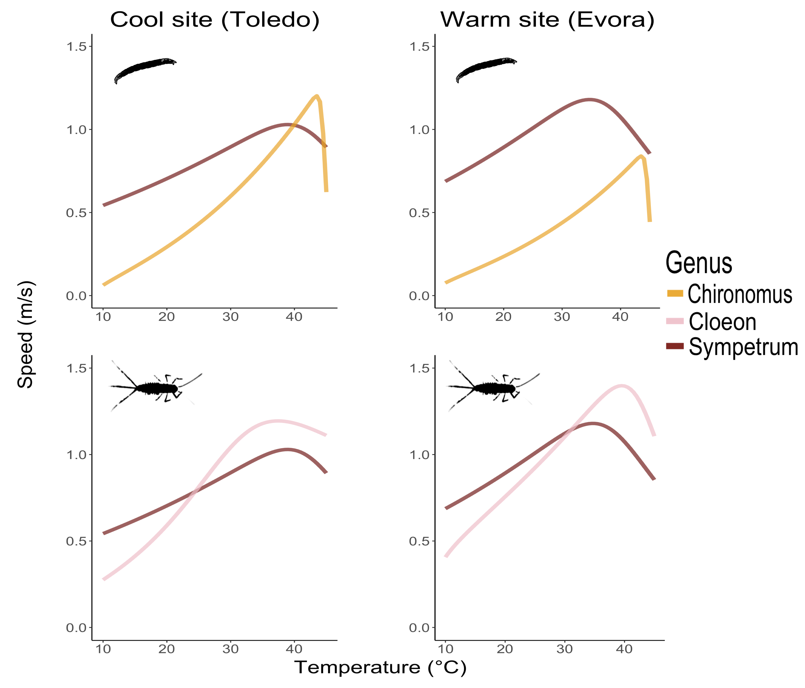

Figure 5. **Mismatches in velocity performance with temperature will lead to changes in species interactions.** Predator-prey velocity curves for mild Toledo versus hot Évora for each predator-prey pair show mismatches in elevation and peak performance temperature. Changes in relative performance in warmer environments place both prey taxa under higher pressure from predation as *S. striolatum* displays relatively higher velocity over much of the operational temperature range.

EFFECT OF TEMPERATURE ON SEARCH AND ENCOUNTER RATE

For both species pairs and all strategies at both sites, we find an exponential increase in search rates (Figure 6). The active 2D strategy displayed the highest search rates over the OTR in all cases. These were followed by 2D sessile prey model predictions for *Chironomus* spp. and 3D active prey predictions for *C. dipterum*. Search rates for the 3D sessile prey model were consistently smaller for both species pairs at each site. The remaining 3D strategy fell in between for *Chironomus* spp. whilst the last sessile strategy took that position for *C. dipterum*.

Activation energies of sessile search rate models increased by the same amount for both species pairs after warm adaptation (Figure 7). In contrast, *Ea* increased for active strategies for *Chironomus* spp. but decreased for *C. dipterum*. The elevation of search rate curves increased with adaptation to a warm environment irrespective of strategy for *Chironomus* spp. This increase was strongest for active strategies and for the 2D alternative in each foraging strategy. *C. dipterum* 3D and sessile 2D strategies increased in *b0* with warm adaptation. We found a small decrease in elevation for the *C. dipterum*’s active 2D model although large confidence intervals overlap with 0.

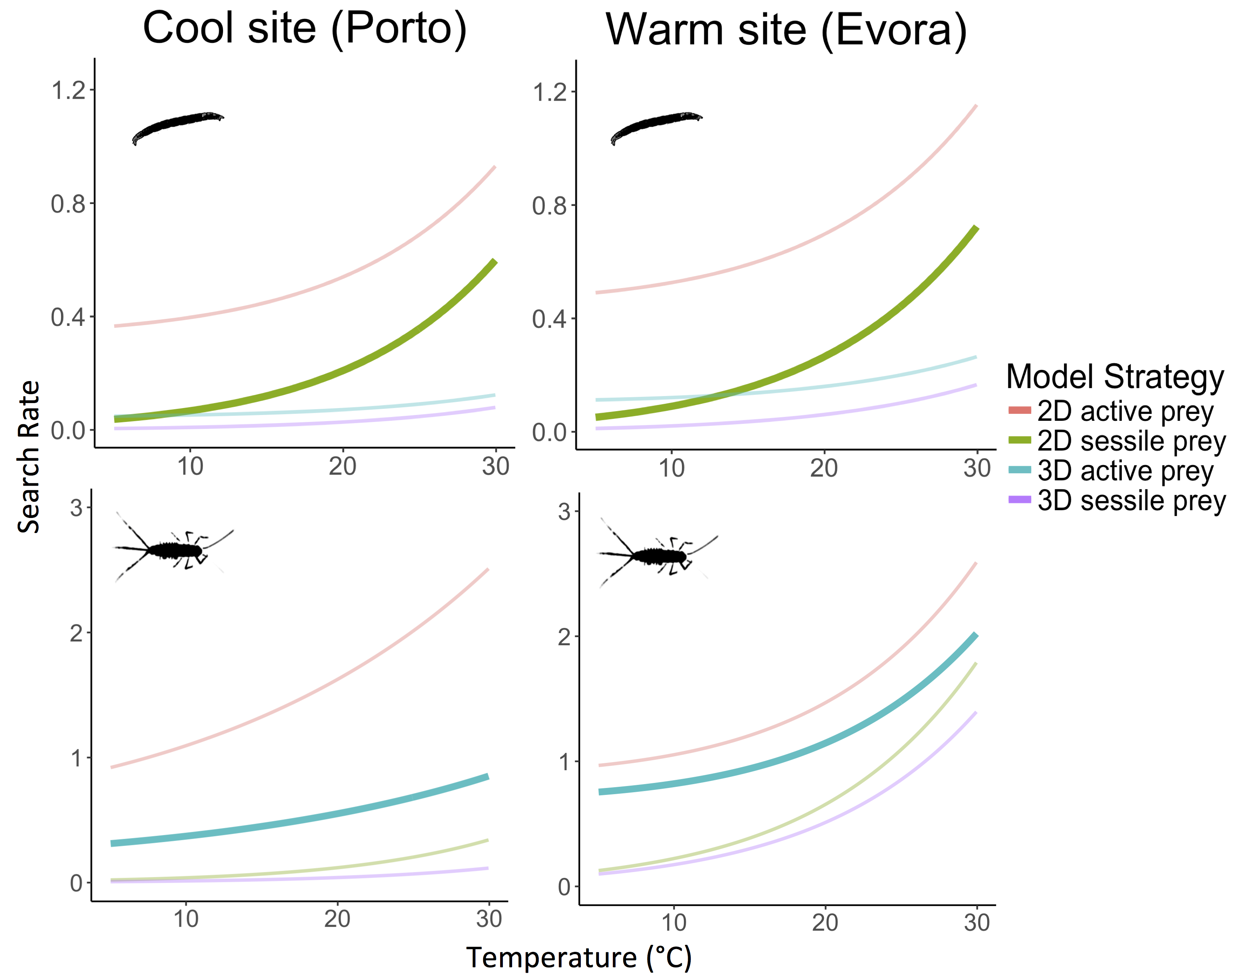

Figure 6. **Modelling search rates according to mechanistic parameters reveals that consistent patterns emerge in all scenarios.** Search rate models' predictions for spp. and *C. dipterum* in mild Porto or warm Évora show similar predictions in search rates within the OTR. Darker shaded curves correspond to the most biologically relevant model for the interacting pair. The model predicts exponential increases in search rate with temperature. Yet, this exponential increase is not as strong for all strategies and appears stronger in warm adapted pairs.

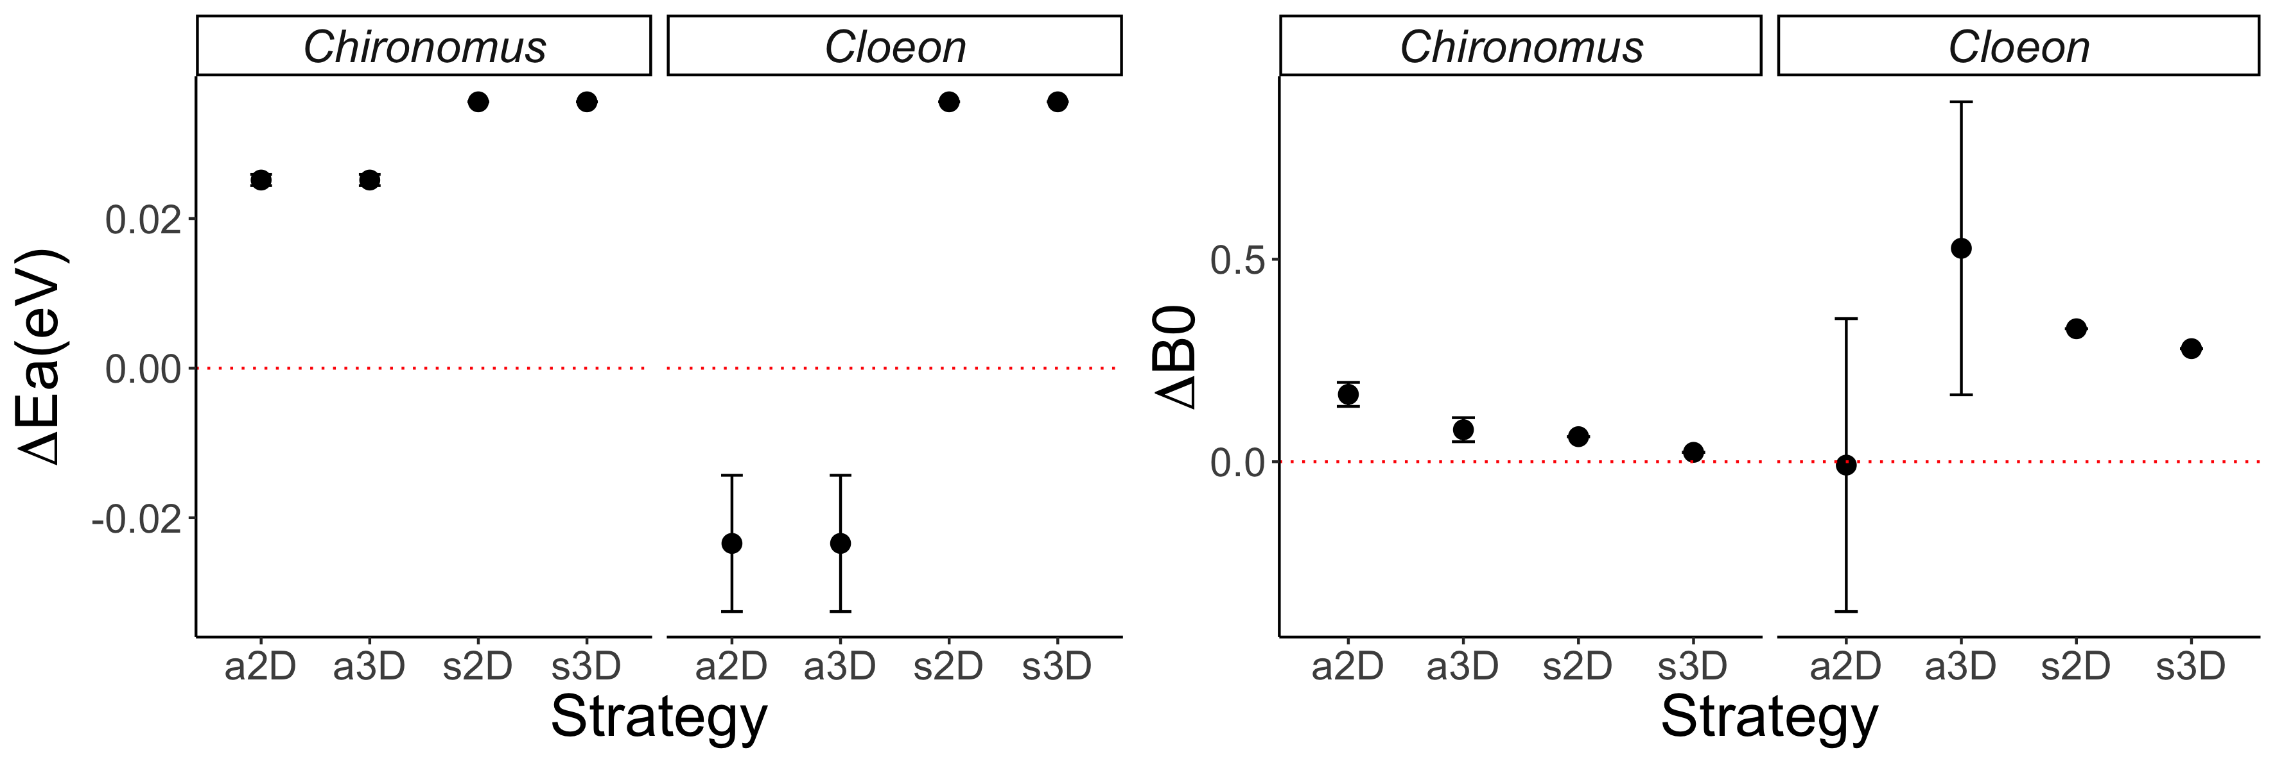

Figure 7. **Differences in search rate activation energy and elevation between warm and cold acclimated reveal species specific responses to temperature.** Search rates for *Chironomus* spp.display an increase in both elevation (Δ*b0*) and activation energy (Δ*Ea*) for all strategies after adaptation to a warm site. Similarly, *C. cloeon* elevation increases for all strategies but active 2D, although large confidence intervals suggest a possible increase. In contrast, *C. cloeon* activation energy decreases for both active strategies in warm adapted taxa.

**Discussion**

Species-specific population temperature performance curves in this study display a vertical shift in the whole curve with increasing temperature (Figures 1B and 3). We did not observe any significant horizontal shift in the TPCs, typical of a shift in optimal performance temperature determined by trade-offs of performing better at higher temperatures and thus worse at lower ones (Figure 1C). The three taxa in this study have adapted their physiology by modifying their TPCs to better utilise the increase in available energy with temperature. Yet, this observed increase is not monotonous or consistent between species. Whilst the predatory dragonfly TPCs increase in elevation as they adapt to hotter sites such a relationship is not observed in their prey (Figures 3 and 4). Both prey species display lower elevation at temperature extremes than intermediate temperatures, suggesting a potential optimum adaptation towards the mid-range temperatures of the OTR. Furthermore, it is worth noting that the value for *Tpk* is higher than the operational range of temperature (Figure 3). Displaying *Tpk* values at unrealistically high temperatures of 35 °C or more provides a margin of safety to these taxa should climate change bring ambient temperatures higher than they currently are.

Converting metabolic rate measurements into velocity, a key driver of species interactions (Dell *et al.*, 2014), enables us to directly consider the potential mismatch in trait performance between a prey and its predator (Figures 1D&E and 5). Our study suggests that species adapt to new environments within the limits imposed by their physiology and phenotypic plasticity, which will lead to differing changes in performance and thus interaction types and strengths (Angilletta, 2009; Kordas *et al.*, 2011; Gibert and De Long, 2014; Pawar *et al.*, 2015). In this case, the predatory dragonflies of this species may be better able to feed on both these prey speciesthroughout their OTR as they are able to move faster, increasing potential attack and capture rates. Despite an increase in both prey velocity TPCs elevation, the increase in that of their predator causes a stronger mismatch in hotter environments. The monotonous increase in *S. striolatum* respiration *b0* measured here suggests this predator may be better suited at adapting to a warmer environment thus benefiting disproportionately from such environmental changes. Decreased oxygen concentration in warm water (Gilbert *et al.*, 2005) may be limiting both *C. dipterum*’s and *Chironomus* spp.’s ability to adapt to hotter environments. Indeed, mayfly and chironomid species are very sensitive to low *O2* environments (Panis *et al.*, 1996; Bauernfeind and Soldan, 2012). These results suggest that although species may adapt to an environment in similar ways, the magnitude of their scope for adaptation may cause new mismatches that will be detrimental to a species despite the apparent benefit of a warmer environment.

Predator-prey interactions are key to community-level dynamics in aquatic environments (Pawar *et al.*, 2015). Here we show that it is possible to predict the behaviour of search rates from a mechanistic model relying on metabolic rates data. We find support for an exponential increase in search rates with temperature (Brown *et al.*, 2004, Vuvic-Pestic *et al.*, 2011, Rall *et al.*, 2012). This relationship is maintained across foraging strategies but the magnitude of the increase varies, underlying the importance of environmental dimensionality in species interactions (Pawar *et al.*, 2012). The strength of the relationship between search rates and temperature depends both on dimensionality and on the species operating in that space (Figure 6). Here, we find that dimensionality is playing a stronger role in search rates for *Chironomus* spp. whilst foraging strategy drives increased search rates in *C. dipterum*. Indeed, 2D environments display the sharpest increase for the former whilst it is active strategies for the latter. Thus, although biochemical processes result in similar patterns of search rate increase with warm adaptation, it is important to consider specific prey items and the environment they interact in when modelling search rates. Nonetheless, the overall increase in search rate elevation in warm adapted species (Figure 7) suggests that as the difference in performance of velocity increases, so do search rates. These results support the idea that the predator in this study will benefit disproportionately from the warming of its environment.

The set of assumptions of this model may limit its application to all types of predator-prey pairs. First, random movement has been shown to approximate animal dispersion in most cases but may not suffice in all (Pawar *et al.*, 2015). Second, the effect of dimensionality is largely dependent on the environment and the predator’s detection mechanism, as *d0* (minimum detection distance) will depend both on the medium and trait used (Pawar *et al.*, 2012). Third, the model uses an established relationship for general forms of movement in water and cost of transport (Tucker, 1970; Videler and Nolet, 1990; Videler, 1993). Alternatives can be used based on specific locomotion techniques and the physics involved therein but this was not available for our species (Alexander, 2003). We suggest that this drawback is only minor, for it is much easier to find information on higher taxa’s locomotion and work is on-going on the physics of animal movement with regard to metabolism (Hein *et al.*, 2012; Gibert *et al.*, 2016). However, these shortcomings all point towards the fact that more empirical work on life history, habitat choice and animal movement is needed for a better integration of computational methods into biological studies. Finally, for ease of study and because no such information was available, we ignored energetic budgets and assumed that all the energy produced by metabolism was used for locomotion. This assumption will be broken in all cases as the energy produced by metabolism needs to be allocated to several other biological needs, such as growth and maintenance. Furthermore, of the energy allocated to locomotion, a large amount will be lost due to muscular inefficiency in most animals (Alexander, 2003). Indeed, up to 60% of the energy allocated for muscle contraction may be lost due to this inefficiency (Tucker, 1975). Although these assumptions are most likely affecting our results, we suggest that this model can, and should, be easily adapted for taxa where more information is available and may lead to predictions that can be validated empirically. This in turn would be hugely beneficial in studies on the effects of global warming on the dynamics of predation as search rates are notoriously complicated to estimate experimentally (Rall *et al.*, 2010; Vucic-Pestic *et al.*, 2011).

The link between metabolic rates, velocity, their scope for adaptation and its effect on species interactions can be understood via mechanistic modelling. Species-specific metabolic adaptation to warmer environments (Figure 3), via changes in *b0* and *Ea* (Figure 4), transfers directly to mismatches in biological traits (Figure 5) and is recovered in search rate adaptation to temperature (Figure 6). The current increase in understanding of trait temperature-dependence and the mechanics of movement enabled the design of a biologically representative model based on empirical data gathered in the field. We reveal the patterns of thermal adaptation in a set of Iberian aquatic invertebrates and show how theoretical models enable qualitative predictions of complex biological traits and species interactions. Future work should focus on integrative approaches linking theoretical predictions to measured empirical data to understand the multi-level processes affecting thermal ecology. There is still much to understand about the effect temperature plays on metabolism and all the processes it controls. In the light of recent global warming, it is thus crucial that more effort be focused on the role temperature plays in all things related to life on Earth.

**Acknowledgements**

Special thanks go to Dr Katarzyna Sroczynska and Miss Càtia Lucio Pereira for their support in collecting the data used in this study.

**Authors contribution statement**

F. Affinito, M. Matias, S. Pawar and R. Kordas conceived the ideas and designed methodology;

F. Affinito, M. Matias and R. Kordas collected the data;

F. Affinito analysed the data;

F. Affinito led the writing of the manuscript.

M. Matias, S. Pawar and R. Kordas revised and corrected the manuscript.

All authors contributed critically to the drafts and gave final approval for publication.

**References**

Albouy, C., Velez, L., Coll, M., Colloca, F., Loc’h, F., Mouillot, D., and Gravel, D. (2014). From projected species distribution to food-web structure under climate change. Global change biology, 20(3):730–741.

Alexander, R. M. (2003). Principles of animal locomotion. Princeton University Press. Amarasekare, P. and Savage, V. (2011). A framework for elucidating the temperature dependence of fitness. The American Naturalist, 179(2):178–191.

Angilletta, M. J. (2006). Estimating and comparing thermal performance curves. Journal of Thermal Biology, 31(7):541–545. Angilletta, M. J. (2009). Thermal adaptation: a theoretical and empirical synthesis. Oxford University Press.

Atkinson, D. (1994). Temperature and organism size: a biological law for ectotherms? Advances in ecological research, 25:1–1.

Bauernfeind, E. and Soldan, T. (2012). The Mayflies of Europe (Ephemeroptera). Brill.

Brodersen, K. P., Pedersen, O., Walker, I. R., and Jensen, M. T. (2008). Respiration of midges (diptera; chironomidae) in british columbian lakes: oxy-regulation, temperature and their role as palaeo-indicators. Freshwater Biology, 53(3):593–602.

Brown, J. H., Gillooly, J. F., Allen, A. P., Savage, V. M., and West, G. B. (2004). Toward a metabolic theory of ecology. Ecology, 85(7):1771–1789.

Clements, C. F., Collen, B., Blackburn, T. M., and Petchey, O. L. (2014). Effects of directional environmental change on extinction dynamics in experimental microbial com- munities are predicted by a simple model. Oikos, 123(2):141–150.

Coley, P. D., Bryant, J. P., and Chapin III, F. S. (1985). Resource availability and plant antiherbivore defense. Science, 230:895–900.

Cranston, P. S., Pinder, L. C. V., and Armitage, P. D. (1995). The Chironomidae : biology and ecology of non-biting midges / edited by P.D. Armitage, P.S. Cranston, L.C.V. Pinder. Chapman Hall London.

Dell, A. I., Pawar, S., and Savage, V. M. (2011). Systematic variation in the temperature dependence of physiological and ecological traits. Proceedings of the National Academy of Sciences, 108(26):10591–10596.

Dell, A. I., Pawar, S., and Savage, V. M. (2014). Temperature dependence of trophic interactions are driven by asymmetry of species responses and foraging strategy. Journal of Animal Ecology, 83(1):70–84.

DeLong, J. P. (2012). Experimental demonstration of a rate–size trade-off governing body size optimization. Evolutionary Ecology Research, 14(3):343–352.

DeLong, J. P., Brassil, C. E., Erickson, E. K., Forbes, V. E., Moriyama, E. N., and Riekhof, W. R. (2017a). Dynamic thermal reaction norms and body size oscillations challenge explanations of the temperature–size rule. Evolutionary Ecology Research, 18(3):293–303.

DeLong, J. P., Gibert, J. P., Luhring, T. M., Bachman, G., Reed, B., Neyer, A., and Montooth, K. (2017b). The combined effects of reactant kinetics and enzyme stability explain the temperature dependence of metabolic rates. Ecology and evolution.

Elzhov, T. V., Mullen, K. M., Spiess, A.-N., and Bolker, B. (2016). minpack.lm: R In- terface to the Levenberg-Marquardt Nonlinear Least-Squares Algorithm Found in MIN- PACK, Plus Support for Bounds. R package version 1.2-1.

Frazier, M., Huey, R. B., and Berrigan, D. (2006). Thermodynamics constrains the evo- lution of insect population growth rates:warmer is better. The American Naturalist, 168(4):512–520.

Gibert, J. P., Chelini, M.-C., Rosenthal, M. F., and DeLong, J. P. (2016). Crossing regimes of temperature dependence in animal movement. Global change biology, 22(5):1722– 1736.

Gibert, J. P. and DeLong, J. P. (2014). Temperature alters food web body-size structure. Biology letters, 10(8):20140473.

Gilbert, D., Sundby, B., Gobeil, C., Mucci, A., and Tremblay, G.-H. (2005). A seventy-two- year record of diminishing deep-water oxygen in the st. lawrence estuary: The northwest atlantic connection. Limnology and Oceanography, 50(5):1654–1666.

Gillooly, J. F., Brown, J. H., West, G. B., Savage, V. M., and Charnov, E. L. (2001). Effects of size and temperature on metabolic rate. science, 293(5538):2248–2251.

Hein, A. M., Hou, C., and Gillooly, J. F. (2012). Energetic and biomechanical constraints on animal migration distance. Ecology letters, 15(2):104–110.

Holling, C. S. (1959). Some characteristics of simple types of predation and parasitism1. The Canadian Entomologist, 91(7):385–398.

Houghton, J. T. (1996). Climate change 1995: The science of climate change: contribution of working group I to the second assessment report of the Intergovernmental Panel on Climate Change, volume 2. Cambridge University Press.

Hughes, L. (2000). Biological consequences of global warming: is the signal already ap- parent? Trends in ecology & evolution, 15(2):56–61.

Kingsolver, J. G. (2009). The well-temperatured biologist: (american society of naturalists presidential address). The American Naturalist, 174(6):755–768.

Knies, J. L., Kingsolver, J. G., and Burch, C. L. (2009). Hotter is better and broader: thermal sensitivity of fitness in a population of bacteriophages. The American Naturalist, 173(4):419–430.

Kordas, R. L., Harley, C. D., and O’Connor, M. I. (2011). Community ecology in a warming world: the influence of temperature on interspecific interactions in marine systems. Journal of Experimental Marine Biology and Ecology, 400(1):218–226.

Long, Y., Hu, C., Shi, B., Yang, X., and Hou, M. (2012). Effects of temperature on mate location in the planthopper, nilaparvata lugens (homoptera: Delphacidae). Environ- mental entomology, 41(5):1231–1238.

Loreau, M., Naeem, S., Inchausti, P., Bengtsson, J., Grime, J., Hector, A., Hooper, D., Huston, M., Raffaelli, D., Schmid, B., et al. (2001). Biodiversity and ecosystem functioning: current knowledge and future challenges. science, 294(5543):804–808.

Luhring, T. M. and DeLong, J. P. (2016). Predation changes the shape of thermal performance curves for population growth rate. Current Zoology, 62(5):501–505.

McGill, B. J. and Mittelbach, G. G. (2006). An allometric vision and motion model to predict prey encounter rates. Evolutionary Ecology Research, 8(4):691–701.

Merritt, R. W. and Cummins, K. W. (1996). An introduction to the aquatic insects of North America. Kendall Hunt.

Panis, L. I., Goddeeris, B., and Verheyen, R. (1996). On the relationship between vertical microdistribution and adaptations to oxygen stress in littoral chironomidae (diptera). Hydrobiologia, 318(1-3):61–67.

Pawar, S., Dell, A. I., and Savage, V. M. (2012). Dimensionality of consumer search space drives trophic interaction strengths. Nature, 486(7404):485.

Pawar, S., Dell, A. I., and Savage, V. M. (2015). From metabolic constraints on individ- uals to the dynamics of ecosystems. Aquatic functional biodiversity: an ecological and evolutionary perspective, pages 3–36.

Peñuelas, J. and Filella, I. (2001). Responses to a warming world. Science, 294(5543):793– 795.

R Core Team (2015). R: A language and environment for statistical computing.

Rall, B. C., Brose, U., Hartvig, M., Kalinkat, G., Schwarzmu ̈ller, F., Vucic-Pestic, O., and Petchey, O. L. (2012). Universal temperature and body-mass scaling of feeding rates. Phil. Trans. R. Soc. B, 367(1605):2923–2934.

Rall, B. C., Vucic-Pestic, O., Ehnes, R. B., Emmerson, M., and Brose, U. (2010). Tem- perature, predator–prey interaction strength and population stability. Global Change Biology, 16(8):2145–2157.

Rogers, D. (1972). Random search and insect population models. The Journal of Animal Ecology, pages 369–383.

Savage, V. M., Gillooly, J. F., Brown, J. H., West, G. B., and Charnov, E. L. (2004). Effects of body size and temperature on population growth. The American Naturalist, 163(3):429–441.

Saxe, H., Cannell, M. G., Johnsen, Ø., Ryan, M. G., and Vourlitis, G. (2001). Tree and forest functioning in response to global warming. New Phytologist, 149(3):369–399.

Schoolfield, R., Sharpe, P., and Magnuson, C. (1981). Non-linear regression of biological temperature-dependent rate models based on absolute reaction-rate theory. Journal of theoretical biology, 88(4):719–731.

Sharpe, P. J. and DeMichele, D. W. (1977). Reaction kinetics of poikilotherm development. Journal of Theoretical Biology, 64(4):649–670.

Stocker, T. (2014). Climate change 2013: the physical science basis: Working Group I contribution to the Fifth assessment report of the Intergovernmental Panel on Climate Change. Cambridge University Press.

Tucker, V. A. (1970). Energetic cost of locomotion in animals. Comparative Biochemistry and Physiology, 34(4):841–846.

Tucker, V. A. (1975). The energetic cost of moving about: walking and running are extremely inefficient forms of locomotion. much greater efficiency is achieved by birds, fishand bicyclists. American Scientist, 63(4):413–419.

Videler, J. and Nolet, B. (1990). Costs of swimming measured at optimum speed: scale effects, differences between swimming styles, taxonomic groups and submerged and sur- face swimming. Comparative Biochemistry and Physiology Part A: Physiology, 97(2):91– 99.

Videler, J. J. (1993). Fish swimming, volume 10. Springer Science & Business Media.

Vucic-Pestic, O., Ehnes, R. B., Rall, B. C., and Brose, U. (2011). Warming up the system: higher predator feeding rates but lower energetic efficiencies. Global Change Biology, 17(3):1301–1310.

Yvon-Durocher, G., Caffrey, J. M., Cescatti, A., Dossena, M., del Giorgio, P., Gasol, J. M., Montoya, J. M., Pumpanen, J., Staehr, P. A., Trimmer, M., et al. (2012). Reconciling the temperature dependence of respiration across timescales and ecosystem types. Nature, 487(7408):472.

**Supplementary Material**

LENGTH-WEIGHT REGRESSION

Between 50 and 100 individuals of all three tax “types”, *Odonata*, *Ephemeroptera* and *Chironomidae*, were used in each length-weight regression experiments. Each individual was measured under the microscope and placed in an individual foil cup. All cups were labeled and left in an oven at 80*°C* for 16 to 18 hours. Dry-weight measurements were then done for each individual in turn. The obtained length and biomass measurements were then fitted to two different linear models, one with dry-weight logged and not the other. The best-fit model (highest *R2*) was kept. Only *Odonata* and *Ephemeroptera* linear models yielded satisfactory fit (*R2* > 0.6) and were thus kept. The length-weight regression for *Chironomidae* was taken from (?). The equations for *Odonata* and *Ephemeroptera* and corresponding *R2* values can be found in table S2.

RESPIROMETRY PROTOCOL

All individuals selected for respirometry experiments were initially stored in filtered pond water kept at ambient temperature. These were then placed in a water bath, previously heated at the experimental temperature, for 15min to allow them an acclimation time from their ambient temperature storage to the new temperature. After acclimation, individuals were placed in glass chambers, filled with fully oxygenated filtered pond water, of 4, 2 or 0.75 *ml* depending on the size of the organism. These chambers were then placed in the respirometry apparatus inside the water bath. A total of eight chambers was used per experimental trial, one control -empty- chamber and seven treatment -organism- chambers. A Unisense O2 optical measuring probe was used to measure oxygen consumption over time in the chambers, three readings were recorded for each chamber in order to measure the slope of O2 consumption. This value was corrected for individual chamber volumes and the value of the control was subtracted from the treatment slopes to account for any respiration occurring in the chambers due to microorganisms. This slope value was then used as the value for oxygen consumption of the organism at the corresponding experimental temperature in all subsequent analysis.

RESPIRATION MODEL CHOICE

A simplified version ignoring low temperature inactivation of the mechanistic model for respiration designed by Sharpe & Schoolfield (Schoolfield *et al.*, 1981) was used to fit the respirometry data. Three variants of this model were tested for each species at each site. The model is as follows:

Where *B* is oxygen consumption rate, *B0* is the normalisation constant at 15*°C*, *Ea* is the enzyme’s activation energy, *Ed* is its deactivation energy, *k* is Boltzmann’s constant, *T* is temperature and *Tpk* is the temperature at which *B* is maximised.

The normalisation constant scales with mass as follows:

Where *m* is mass, *β* is the scaling exponent and *b0* is the normalisation constant of the Arrhenius model.

Thus, three Sharpe-Schoolfield models were run with different scalings for *b0*. One model where mass scaling was ignored (*B0* = *b0*), one where *B*0 scaled with mass according to the metabolic theory of ecology (*β* = 0.75, (Brown et al., 2004)) and one where mass scaling was left free and β was estimated from the data along with all other parameters of the model. For each species at each site, 10,000 models of each type were run, the best fit model was selected based on the overall mean fit (*R2*), AIC and BIC values of all runs (Table S3).

1. Correspondence : flavio.affinito@gmail.com